**JDBC Program to execute Create Statement.**

package create;

import java.sql.*;

public class Create {

public static void main(String[] args) {

try{

Class.forName("com.mysql.jdbc.Driver");

Connection con=DriverManager.getConnection("jdbc:mysql://localhost:3306/Employee", "root", "Asusk555l");

System.out.println("Connection Established Successfully");

Statement st=con.createStatement();

int n=st.executeUpdate("create table Emp1(id integer,name varchar(40),designation varchar(40))");

ResultSet rs=st.executeQuery("Select * from Emp1");

while(rs.next())

{

int id=rs.getInt(1);

String name=rs.getString(2);

String post=rs.getString(3);

System.out.println(id+ "\t" +name+ "\t" +post);

}

}catch(Exception e)

{

System.err.println(e);

}

}

}

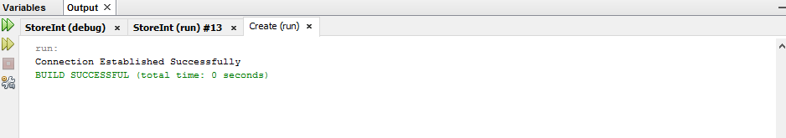

**JDBC Program to execute Insert Statement.**

package psinsert;

import java.sql.Connection;

import java.sql.*;

public class PSInsert {

public static void main(String[] args) {

try{

Class.forName("com.mysql.jdbc.Driver");

Connection con=DriverManager.getConnection("jdbc:mysql://localhost:3306/Employee","root","Asusk555l");

PreparedStatement ps=con.prepareStatement("insert into emp values(?,?,?)");

ps.setString(1,"Pranu");

ps.setInt(2,109);

ps.setString(3,"Ap");

int n= ps.executeUpdate();

System.out.println("No. of rows inserted\n "+n);

}catch(Exception e)

{

System.out.println(e);

}

}

}

